Group A Leadership Plan for Inclusive Education: Marion McVeety Elementary School

Deidra Anderson Doll, Patricia Ives, Geetu, Cynthia Smith, and Erin Wittal
Department of Graduate Studies, University of Regina
EDL 828: Leadership for Inclusive Education
Dr. Corey Hadden
July 22, 2021

Contents
Group A Leadership Plan for Inclusive Education: Marion McVeety Elementary School ……... 3
Overview of Marion McVeety …………………………………………………………………... 4
Overview of the Plan ……………………………………………………………………………. 6
Inclusive School Reform Framework
Step 1: Setting Up the Vision
Step 2: What is Happening Now
Step 3: Align School Structures
Step 4: Creating Instructional Teams
Step 5: Improving Classroom Practices
Step 6: Ongoing Monitoring, Adjusting, and Celebrating
Step 7: Ongoing: Create a Climate of Belonging
Conclusion
References
Appendices
Group A Leadership Plan for Inclusive Education: Marion McVeety Elementary School
Educational paradigms shift to reflect ever-changing societal attitudes that have become more accepting of individual differences and appreciative of the strengths found in diversity. Schools are recognizing that, “This is the critical responsibility of every school leader and administrator: ensuring that all students are provided with the instruction - academic, social, and physical - to which they have a legitimate and inherent right as citizens of a given community” (Edmunds & Macmillan, 2010, p. 16). The purpose of this paper is to collaboratively develop a leadership plan for inclusive education for a Saskatchewan school. Marion McVeety Elementary School was chosen as they have exhibited a climate of belonging, based on the virtues associated with the school’s focus statement, POWER (see Figure 1), and are poised to embrace further inclusionary practices. To incorporate and reflect the shift to a full-inclusive school environment, Marion McVeety Elementary School will advance a new focus statement, MUSTANGS (see Figure 5). This assignment assesses the existing inclusive environment, attitudes, structures, and processes at Marion McVeety Elementary School in Regina, Saskatchewan. Using the assessment as a starting point, a plan is envisioned that will propel Marion McVeety forward in its inclusionary goals. The Inclusive School Reform framework (Causton & Theoharis, 2014, pp. 49-54) is applied to the needs and strengths identified in the assessment. The framework steps are explored in detail and evidence is provided to support their inclusion in the vision for change. By following the steps of the detailed framework, school leaders ensure that there is a shared vision and commitment contributing to a celebration of diverse perspectives and the strengths of all.

Figure 1
POWER
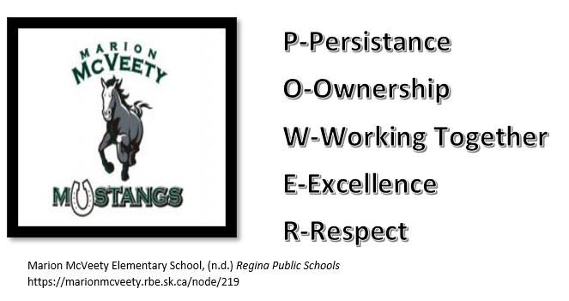
Overview of Marion McVeety
Marion McVeety is an elementary school in South Regina. Enrollment fluctuates daily and the school community is transient. Currently the school population is 342 students. Of this population, 203 are English as an Additional Language Learners (EAL), and 20 are First Nations Metis and Indigenous (FNMI) students. There are 18 students with Inclusion and Intervention Plans (IIP), 46 students with a Record of Adaptations (ROA), and 12 who use assistive technology. Six students were approved for Intensive Needs programs (three for Primary Transitions Kindergarten and three for Grade 9 Vocational Adaptation Program (VAP)). Those receiving division support include: two educational psychologist referrals, two occupational therapist referrals, 12 students working with the school counsellor, and 25 students receiving Speech and Language Support (SLP). The SLP support is focused primarily on kindergarten to Grade 3.
Diversity is prominent as students from over 30 countries attend this school. Per capita, Marion McVeety is the number one school to receive students from the Newcomer Welcome Centre. There are 13 classrooms ranging from Pre-Kindergarten to Grade 8. Staffing is as follows:
Staffing for Marion McVeety School
Full Time | Part Time and Shared Staff
Principal
Vice-Principal (.3)
Administrative Assistant
Head Facility Technician | Evening Caretaker
13 Classroom Teachers
1 Pre-Kindergarten Associate | .5 Early Learning Intensive Support Program (ELISP) Associate (Pre-K)
2 Specialist Teachers  (Arts Education & French) | .2 Specialist  (Physical Education)
.2 Specialist
(Literacy)
 | .5 Librarian
English as an Additional Language Teacher | .3 English as an Additional Language Teacher
5 Educational Assistants
 | .3 Speech and Language Pathologist

Note: school counsellor, educational psychologist, occupational therapist, and school resource officer services are shared between schools within the Regina School Division.
Due to the high EAL population, Marion McVeety is assigned two Settlement Support Worker in Schools (SSWIS), one Arabic-speaking and one Mandarin-speaking. Requests for support from the SSWIS workers are initiated by educators and go through the principal and EAL teacher.
The Pre-Kindergarten classroom has two spaces for the Early Learning Intensive Support Program (ELISP). This program is funded through the Canada-Saskatchewan Early Learning and Child Care Agreement. The goal of this program is to provide opportunities for children with intensive needs to be included in early learning opportunities and build the foundations for success.
Overview of the Plan
The leadership plan for Marion McVeety is framed around an immersive school environment for inclusion. Collaboration between all stakeholders is imperative for success. The leaders of Marion McVeety are revolutionizing the inclusive process by instilling inclusive practices in the values of the school. These values are seen in everyday interactions and the welcoming environment of the school itself. Steps are taken to provide a shared vision, realign organizational structures including service delivery, inclusive classroom instruction that is supported by all, and sense of belonging and acceptance within the school community. Careful planning and consideration are evident in all aspects of the detailed plan where ongoing evaluation and revision is paramount to the success for inclusive reform.
The framework used in the development of this leadership plan is the Inclusive School Reform by Causton & Theoharis (2014). The framework was created in consultation with the Planning Alternative Tomorrows with Hope (PATH) framework. PATH focuses on a person-centred planning (PCP) approach where the student outcome is paramount in the planning process (Wood et al., 2019). PCP uses humanistic and positive psychology as theoretical frameworks to focus on increasing a student’s quality of life, enhancing their growth and development, and creating meaningful change for students. The PATH process itself has reported an increase in confidence and motivation, additional support, and a sense of direction for its students (see Appendix A). Additionally, a common theme of child-centredness was identified in PATH studies as students and parents were given a voice in their educational journey (p. 333).
With any model comes limitations. Wood et al. (2019) have identified possible limitations with the PATH model as lack of time, lack of preparation, and lack of human resources such as speech therapists. To overcome these potential barriers, the planning process of any inclusive model is paramount to its success. The school community must be well-versed in the inclusive model and strategies designed by the school. Teachers should be collaborative partners in the change process where there is support for meeting times and preparation. Professional development must also be included during the preparation process (McLesky et al., 2014). Furthermore, an environment of trust between leadership and front-line teachers needs to be developed and built upon. Collaboration, trust, and shared beliefs and values are essential components to ensure success of the Inclusive School Reform process at Marion McVeety (Edmunds & Macmillan, 2010), which is evident as underlying assumptions within the framework.
Causton and Theoharis (2014) have used a strong model during the creation of their seven-part process for Inclusive School Reform which is why this framework was chosen. The aim of the Leadership Plan for Marion McVeety is to strengthen the inclusive learning environment which the Inclusive School Reform framework will enable. The use of this model will ensure the reflection of the shift of societal attitudes where inclusion is respected and valued. Furthermore, Marion McVeety will continue to be well-poised to embrace full inclusionary practices.
Inclusive School Reform Framework
To implement the Causton and Theoharis plan for inclusive school reform, a school leader creates a team consisting of school administrators, general education teachers, special education teachers, and other staff members and go through this process together (Causton & Theoharis, 2014, p. 61). Collaboration of all staff at each step of the process is required.
Figure 2
Inclusive School Reform Planning Tool (Causton & Theoharis, 2014, p. 50)
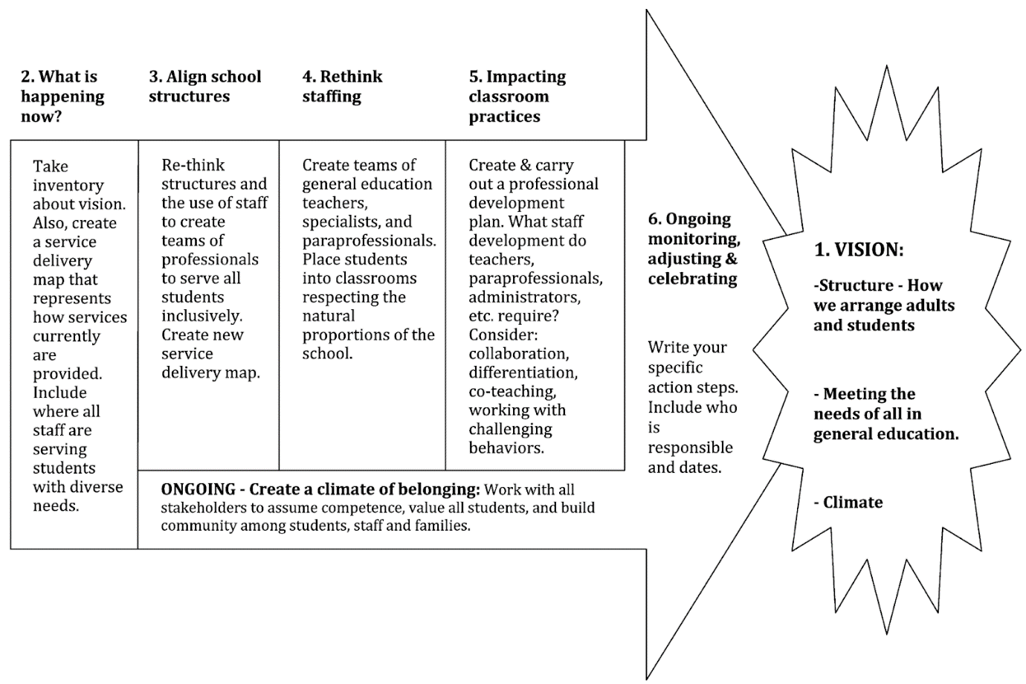
Step 1: Setting Up the Vision
To succeed in achieving an inclusive environment, it is necessary that all involved have a clear, collective vision of the school’s goals. With these on the horizon, it is possible to develop inclusive pathways that decrease barriers and increase shared participation and understanding. Leaders in the school are key “in articulating a vision for inclusion and helping others understand and adopt inclusion as a core value or philosophy” (Causton-Theoharis et al., 2011; Hoppey & McLeskey, 2013; Salisbury, 2006; Waldron et al., 2011, as cited by Billingsley et al. 2018, p. 68). It is clear from Figure 2 that setting a vision is of the utmost importance as all other reforms depend on it. The team needs to set a vision for the school to reform the initiatives “around three areas: 1) the school structure (i.e., how we arrange adults and students), 2) meeting the needs of all in general education, and 3) school climate” (Causton & Theoharis, 2014, p. 49).
The School Structure
When considering the school structures that are needed, the Marion McVeety administrative team should discuss the physical structures, socio-emotional structures, and the communication pathways. Educational human resource supports and resources are to be made available to all students, not set aside solely for students with disabilities. The administrative team will develop a clear, revised Service Delivery Map that outlines the allocation of these. After consultation with the student support team, the principal will make any final decisions regarding any additional resources and supports that are requested.
At Marion McVeety, the shared vision for inclusion ensures that the general education classrooms include and welcome all students, with no exclusion for students with disabilities. “Achieving the demands for improved student outcomes for all students and inclusion of increasing numbers of students with disabilities in general education classrooms requires significant changes in schools” (McLeskey & Waldron, 2006; Waldron & McLeskey, 2010, as cited by Hoppey & McLeskey, 2013, p. 245). Educators at Marion McVeety are to regard the strengths and challenges of learners with and without disabilities.
According to the assessment of Marion McVeety conducted in Step 2 using the Student Support Services Service Delivery Model Rubrics, (see Appendix B), it was evidenced that students receive instruction in heterogeneous groups in the regular classroom. The only need is to support students in a range of age-appropriate, balanced classrooms. The physical structure of the classroom will be suitable for the moment of every child. To check the effectiveness of the plan, a designated person will facilitate monthly communication meetings for staff. The agenda of the meeting will be to discuss the various topics surrounding inclusion and meeting minutes will be maintained (see Appendix I).
Meeting the Needs of All in General Education
At Marion McVeety, the administration will provide a supportive environment for staff that allows for collaborative teaching and differentiated instruction. For these efforts to be successful, the administrative team will arrange scheduled monthly meetings and facilitate vertical communication between the various grade levels and with the support services. Effective communication between all staff is considered a valuable component when setting up an inclusive and positive team environment.
Schools must focus on providing an environment that reduces barriers and any restrictions to academic or social inclusion. Causton and Theoharis (2014) cite the Individuals with Disabilities Education Improvement Act (IDEA) which states “that all students with disabilities have the legal right to be placed in the LRE” (Least Restrictive Environment) (p. 30). Marion McVeety is committed to full inclusion of students with disabilities in all general education classrooms. Teachers and students will be provided with access to assistive aids and services. It is important that teachers and paraprofessionals are trained in the usage of any technological equipment or supportive aids. This will be achieved through ongoing, targeted professional development opportunities. Time and one-on-one training will be provided for teachers or paraprofessionals requiring more intensive instruction. The use of these will allow educators to modify or adapt instruction in the general education classroom and may include changes such as “preferential seating, use of a computer, taped lectures, reduced seat time,” and “assistance of a teacher with special education training” (p. 30). These general education classroom provisions are the preferred method for supporting students, and students will only be pulled out for instruction on a need basis.
School Climate
When developing the shared vision of an improved inclusive environment, the school climate should be a significant factor. At Marion McVeety, the administrative team will “Examine the physical structure to determine locations conducive to planning, supporting, and implementing inclusion at each grade level” (Causton & Theoharis, 2014, p. 49). It is clear from Marion McVeety’s Service Delivery Map that no room or hall is being reserved for the meetings to plan, support, and implement inclusion at each grade level. At this stage, it is necessary for the planning team to arrange one separate place for action of inclusion and to fix a schedule for conferences. To avoid the hassle during working hours, planning is necessary prior to the event. There are certain duties that must be scheduled in a planned way, such as who will attend the meeting and the replacement of the teacher if the subject teacher or class teacher gets a call from higher authorities. The complete description regarding meeting processes and procedures is given in Steps 4 and 6.
The school climate should reflect positive attitudes towards the inclusion of students with disabilities in every aspect of the school. Administration can encourage a rich and positive environment as they “develop and implement approaches and procedures that promote a professional learning community (e.g., collaboration, consensus, agree to disagree respectfully)” (Causton & Theoharis, 2014, p. 49). In facilitating a professional learning community within the school, administrators will act as the lead learner, sharing strategies, modelling active learning, and positively encouraging educators and staff to engage in professional development.
This research indicates that the key elements of effective principal leadership include facilitating the creation of a school culture that is supportive of teachers, developing teachers as leaders within the school (i.e., distributed or shared leadership), and working to develop a collaborative, professional learning community to support teacher learning. (Blase & Blase, 1998; Crow et al., 2003; Keyes et al., 1999; Waldron & McLeskey, 2010, as cited by Hoppey & McLeskey, 2013, p. 246)
Schools that successfully incorporate inclusion are focused on developing staff and working collaboratively to grow as a cohesive group. The principal is the voice that provides direction and guides others in a shared vision for inclusion with a focus on the journey and the goals.
Step 2: What is Happening Now
The Service Delivery Map in Figure 3 illustrates the three-tier format that is used by Regina Public Schools and lists the supports at each step. Marion McVeety school begins the tier process by using the Marion McVeety Teacher Strategy Form (see Appendix C). This form is completed by the classroom teacher and presented at a school team meeting. Through a collaborative process, ideas and support will be provided to the classroom teacher to meet the student’s needs. Additions and revisions were made to the Service Delivery Maps to ensure a more clear, concise, and visual representation of our inclusive plan.
Figure 3
Current Service Delivery Map Tiers

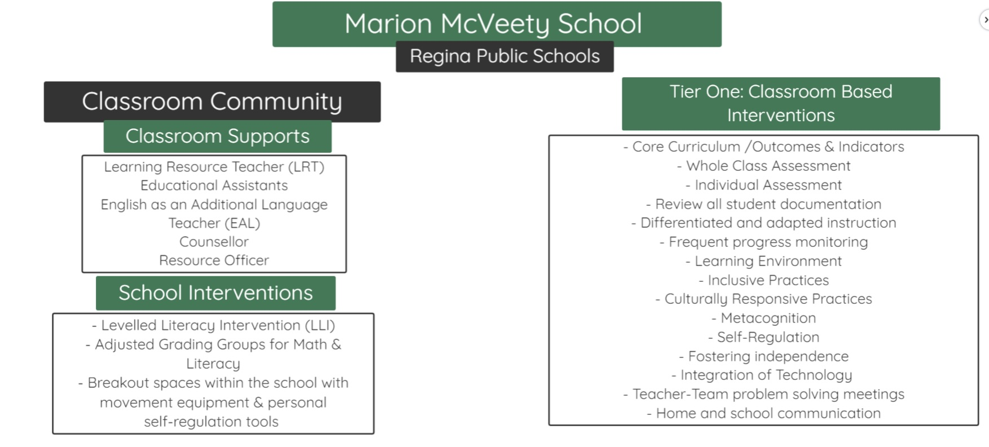
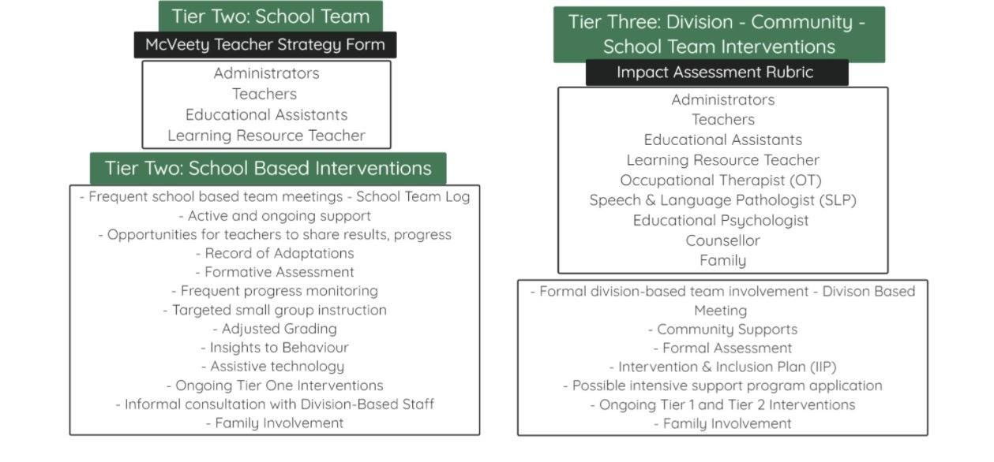

Figure 4
Current Service Delivery Map
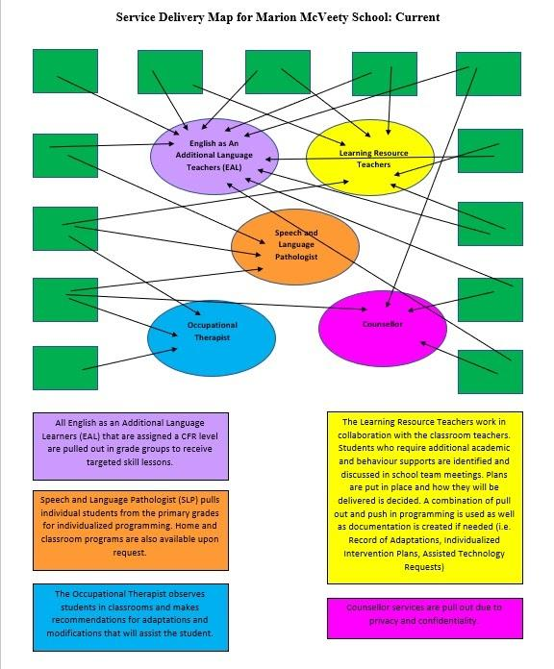

The current Service Delivery Map shown in Figure 4 is complex with overlap between services in classrooms, and classrooms are left with inadequate support to meet student needs. It is recommended that the amount of pull-out instruction is decreased with a move toward more push-in targeted instruction in the child’s classroom. Also, working with staff members to establish and nurture co-teaching partnerships to meet the needs of all students more efficiently is a priority.
At Marion McVeety, it is recognized that “...part of being an engaged citizen ... is acknowledging that there are people who are different from you and that you can learn from them as much as you can accept them” (Timmons & Thompson, 2017, p. 5).
Assessment of Marion McVeety’s Inclusivity
To decide what core elements to work on, it was needed to assess where according to the Student Support Services Service Delivery Model Rubrics (SSSDMR) (see Appendix B), Marion McVeety school was currently operating. The POWER acronym that centers the school community around five main areas (Persistence, Ownership, Working Together, Excellence and Respect) has been a successful focus statement to foster expectations of values and beliefs within the school’s community of learners. Now it is suggested to make the shift away from POWER to a more inclusive model that encourages the school community to come together as a family and embodies inclusive values and beliefs. Using the school mascot, MUSTANGS will be the new, more-inclusive school focus. Each month will be focused around one of the letters, and a collaborative committee will provide books, lessons, and videos to explicitly teach the values and beliefs. Students will be “caught” showing the values and beliefs, and ballot forms will be filled out by school staff for entry in monthly prize draws. Each month, several students will be chosen at random and will be acknowledged at the MUSTANGS assembly. Parents, community members, students, and staff will be invited to celebrate how the MUSTANGS have applied these values and beliefs to their success. A compilation of student work samples, videos, and other examples will be highlighted in a video for all to celebrate. It is the hope that throughout the years Marion McVeety students and staff will be lifelong learners who use the skills, values, and beliefs to become engaged citizens in the school, their communities, and the world.
Figure 5
Mustangs
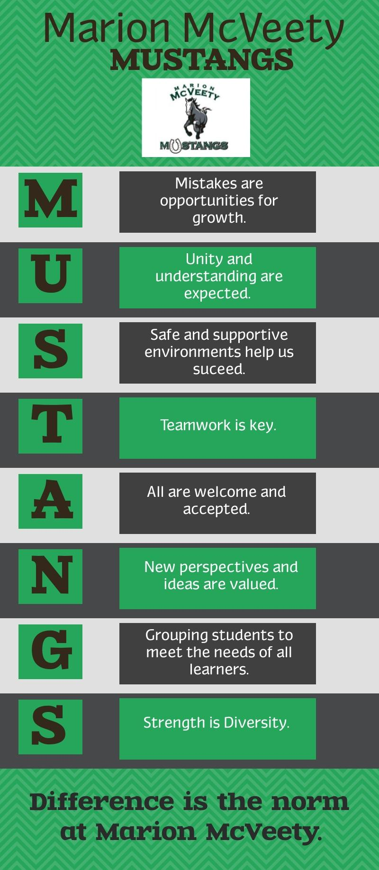

Note. Resources that connect to each section of the MUSTANGS acronym can be found in Appendix D.
Direction for Change
Marion McVeety is well on its way to an being an inclusive school but requires action in some areas according to the Student Support Services Service Delivery Model Rubrics created by the Government of Saskatchewan, Ministry of Education. Marion McVeety’s principal is a strong leader that has implemented many changes towards inclusive education. Inclusive practices, parental/caregiver engagement, planning processes, assistive technologies, behavioral supports, creating a culture of collaboration, and administrative leadership are evident at Marion McVeety. While those are evident, inclusive attitudes, organizational structures, fostering independence, designing instructional programming, support of school personnel, building an interprofessional team and engagement of support agencies are only emerging. The main concern is that professional development is not evident at all. If the school can focus on the emerging skills and install effective professional development, the school will become more inclusive. Achieving the transition will take a while, but the successes will surpass the heavy workload in the beginning. Table 1 shows where Marion McVeety is now; the evident areas are not included, as when the right steps are followed all steps will become exemplary with time. The last column shows the exemplary steps derived from the Student Support Services Service Delivery Model Rubrics. The resources that were accessed to provide supporting information during development of the direction for change were: Inclusive Education: A Guide for School-Based Leaders (Saskatchewan Ministry of Education, 2019), The Principal’s Handbook for Leading Inclusive Schools (Causton & Theoharis, 2014), and A Decade of Professional Development Research for Inclusive Education: A Critical Review and Notes for a Research Program (Waitoller & Artiles, 2013).
Table 1: The Past, Present, and Future
Emerging/Not Evident |  | Exemplary
Emerging Inclusive Attitudes  “School division/school personnel believe that the school division/school has a responsibility to meet the needs of students with diverse and/or intensive needs; teachers attend professional development on inclusive education topics; some classroom teachers express frustrations with inclusion due to inadequate support/resources”  (Saskatchewan Ministry of Education, 2014, p. 1). | “Using staff members (teachers and paraprofessionals) in systematic ways to create service delivery models” (McLesky et al., 2014, p. 84).  “Priority planning includes the following steps: review what supports and services are currently in place; know the learners; define school team members’ roles and responsibilities; prioritize support; create and share the priority plan; implement the plan; and, review and evaluate the plan’s effectiveness (adapted from Kilgore, 2010)”  (Saskatchewan Ministry of Education, 2019, p. 3).  “We know that schools cannot become inclusive or maintain full inclusion without the careful planning, support, and Leadership of good principals” (McLesky et al., 2014, p. 38). | Exemplary Inclusive Attitudes  “School division/school personnel:  a) understand and accept inclusive philosophy,  b) support the inclusion values of participation, belonging, and interaction,  c) recognize the benefits of inclusion for students with and without disabilities,  d) embrace the value of diversity and the importance of creating positive learning communities,  e) use the inclusive philosophy to guide their decision-making,  f) meet the challenges of inclusion with a problem-solving mind-set,  g) acknowledge their responsibility for the education and success of all students” (Saskatchewan Ministry of Education, 2014, p. 1).
Emerging Organizational Structures that Support Inclusive Education  “School division/school personnel discuss the structures that are required to support inclusive education, but actions in this direction are not consistently monitored or implemented” (Saskatchewan Ministry of Education, 2014, p. 2). | “Creating and developing teams who work collaboratively to meet the range of student needs” (McLesky et al. 2014, p. 84).  “Monitoring and adjusting the serviced Systemwide Approach delivery each year” (McLesky et al., 2014, p. 84).  “Designate person to facilitate efficient monthly communication meetings for staff members to discuss various topics surrounding inclusion” (McLesky et al., 2014, p. 84). | Exemplary Organizational Structures that Support Inclusive Education  “School division/schools purposefully develop and implement organizational structures that support inclusion, including:  a) shared vision for inclusion,  b) policies and procedures that are consistent with inclusive philosophy,  c) collaborative work environment,  d) multi-disciplinary teams,  e) administrative support and leadership,  f) professional supports and resources,
Emerging/Not Evident |  | Exemplary
 | “School Climate Goals Examine the physical structure to determine locations conducive to planning, supporting, and implementing inclusion at each grade level.” (McLesky et al., 2014, p. 84). | g) emphasis on teaching and learning,  h) participation in continuous school improvement,  i) educational programming based on effective practice” (Saskatchewan Ministry of Education, 2014, p. 2).
Emerging Fostering Independence  “Students provided with consistent one-on-one adult support for a significant portion of the school day; multi-disciplinary team, including classroom teacher, assess potential reduction in one-on one adult support time allocation in developmentally appropriate sequence; transition planning is in progress to increase student’s independence” (Saskatchewan Ministry of Education, 2014, p. 3). | “Create a schedule that promotes consistent and common planning time for ongoing communication and dialogue” (McLesky et al., 2014, p. 84).  “Provide child-centered, differentiated, research-based instruction that challenges children of all abilities, supported by targeted staff development” (McLesky et al., 2014, p. 84).  “Purposefully working to develop a climate of belonging for students and staff members” (McLesky et al., 2014, p. 84). | Exemplary Fostering Independence  “Student accesses staffing allocation for physical or academic support as required; regular monitoring and adjustment of student’s level of adult support; student explicitly taught skills that facilitate independence and self-determination; positive interdependence with peers fostered to provide support for inclusive activities; purposeful planning and programming for independent living needs; parents/caregivers, classroom teachers, and educational assistants understand the importance of fostering student independence and work together to take purposeful actions that will maximize student independence” (Saskatchewan Ministry of Education, 2014, p. 3).
Emerging Designing the Instructional Program  “Student support services teachers and classroom teachers initially collaborate on instructional plan; attempts made to link instructional plan to IIP; instructional program is specially designed for the student based on necessary functional skills and student’s strengths; some attempts to incorporate evidence-based strategies; classroom teachers recognize the need for differentiated instruction; | “Develop and implement approaches and procedures that promote a professional learning community (collaboration, consensus, agree to disagree respectfully)” (McLesky et al., 2014, p. 84).  “Purposefully build classroom and school climate that is warm and welcoming for children and staff and fosters active/engaging learning” (McLesky et al., 2014, p. 84). | Exemplary Designing the Instructional Program  “School-based team plans and develops a program of instruction, including essential support services; a full range of support services, including natural supports, are considered; instructional plan is aligned with student’s learning profile, IIP, and their response to instruction; instructional program is designed for a range of learner needs (i.e., universal access); evidence-based strategies are used to accomplish educational outcomes;
Emerging/Not Evident |  | Exemplary
students accommodated through parallel instructional activities related to activities of the regular class” (Saskatchewan Ministry of Education, 2014, p .4). | “Have planned opportunities for vertical communication to provide continuity between grade levels” (McLesky et al., 2014, p. 84). | differentiated instruction is common practice and includes adaptations and modifications that reflect differing learning modalities, pacing, and complexity; instruction, assessment, curriculum, and classroom management are aligned; flexible grouping patterns are created based on student’s strengths and needs, and the instructional content; emphasis on self-determination, peer interaction, and the maintenance/generalization of skills; all options for support are considered within the context of:  a) student needs  b) student strengths  c) instructional content  d) need for independence, and  e) social acceptance” (Saskatchewan Ministry of Education, 2014, p. 4)
Emerging Support of School Personnel  “School division in development of guidelines and/or role descriptions for school personnel who work with students with intensive needs; orientation to workplace for new personnel is inconsistent; personnel identify supports required to successfully perform roles, however, there is significantly limited availability and access” (Saskatchewan Ministry of Education, 2014, p. 7). | “Structure Goals (How one arranges adults and students) Place students in balanced classrooms with positive role models” (McLesky et al., 2014, p. 84).  “Meeting the Needs of all in the General Education Classroom Goals” (McLesky et al., 2014, p. 84).  “An essential part of creating service maps is to indicate which staff members pull students from which classrooms, which students learn in self-contained spaces, which paraprofessionals are used where—a complete picture of how and where all staff at the school work” (McLesky et al., 2014, p. 85). | Exemplary Support of School Personnel  “School division provides clearly articulated job descriptions that outline specific roles and responsibilities for all school personnel; school personnel understand and support the roles and responsibilities of their colleagues; systematic planning time is allocated; paperwork requirements are streamlined; school personnel are provided with effective training and/or professional development pertaining to their specific roles; performance expectations are developed for each school personnel role; strategies to facilitate communication and collaboration among staff are developed and implemented; educational assistants are aware of individual and classroom needs prior to working in the classroom;
Emerging/Not Evident |  | Exemplary
classroom teachers are provided with guidance, support, and training pertaining to effective use of
educational assistant support;
mutual respect and positive relationships among staff are evident; school personnel work together to support each other, and accept responsibility for the success of all students; teachers have adequate access to interprofessional team members and supporting agencies to provide ideas, resources, and moral support” (Saskatchewan Ministry of Education, 2014, p. 7).

Emerging Building an Interprofessional Team  “Supporting professionals support school division/ school personnel in some areas, but limited support and access due to supply/demand concerns; supporting professionals communicate independent of each other and have not developed as an interprofessional team; school division has developed processes and guidelines for accessing supporting professionals; supporting professionals consult with teachers on ad hoc and reactive basis; some joint planning, monitoring, and reviewing of learner outcomes, however, no shared responsibility and accountability exists among supporting professionals and school personnel” (Saskatchewan Ministry of Education, 2014, p. 8). | “The focus is on seamlessly providing students the services and supports that they need within the context of general education in order for all students to reach their social and academic potential through developing a school culture in which school staff members embrace a collective ethos that all students are their students and work together to know and respond to students collaboratively. We know this is good not only for students with disabilities, but all students” (Theoharis & Causton, 2014, p. 97). | Exemplary Building an Interprofessional Team  “Interprofessional team members and school personnel working together as collaborative teams to combine expertise and share responsibility for student success; interprofessional team members provide support in all required areas; clear role definitions and accountability parameters (including who reports to whom) is evident; team members emphasize interprofessional trust, collaborative problem-solving, and effective intra-team communication; conflicts are resolved constructively through agreed upon mechanisms and protocols; administrators and teachers have a clear process available to access interprofessional team members; a systematic approach to collection/analysis of diagnostic information exists; interprofessional team members considered an important support network for teachers, offering ideas and resources, and assisting in building teacher capacity and confidence; school division needs are consistently monitored to reflect the consultative needs of school staff;
Emerging/Not Evident |  | Exemplary
 |  | caseloads of interprofessional team members are monitored to ensure effectiveness of service to schools; team members learn new skills and complement the skills of each other” (Saskatchewan Ministry of Education, 2014, p. 8).
Not Evident Effective Professional Development  “Professional development infrequently targeted at areas pertaining to educating students with intensive needs and not part of overall plan to facilitate inclusive education; no professional development expectations for personnel who work with students with intensive needs; no school division induction process for newly hired personnel who work with students with intensive needs” (Saskatchewan Ministry of Education, 2014, p. 8). | “Action research studies evaluated the impact of this type of PD on teacher learning by looking at changes in teachers’ practices and beliefs and attitudes toward inclusive education and students with disabilities. To document these changes, action research studies included observations of teachers’ practices and meetings, surveys and questionnaires, focus groups with teachers and administrators, and teachers’ reflection journals. In general, these studies demonstrated the potential of action research as a form of PD effort to increase teacher confidence and efficacy using an inquiry approach to teaching, create schoolwide programs to foment inclusion, introduce to teachers practices such as differentiated instruction, and challenge teachers’ deficit views of students who struggle to learn” (Waitoller, et al., 2013, p. 331).  “We recommend designing and examining PD efforts using an intersectional approach in which teachers identify and dismantle interesting and multiple barriers to learning and participation for all students. This line of research requires moving beyond the analysis of outcome measures or descriptive processes. It requires a robust theory of how teachers learn in complex contexts in which various institutional and professional boundaries overlap” (Waitoller et al., 2013, p. 347). | Exemplary Effective Professional Development  “Extensive professional development focuses on topics that support inclusive education including: differentiating instruction, evidence-based approaches for instruction, co-teaching, and developing collaborative cultures; school personnel aware of school division expectations of professional development; strong professional development models are used which incorporate:  a) theory and practice,  b) professional reflection time,  c) practices that improve student outcomes,  d) extensive follow-up in classrooms/schools,  e) opportunities for peer dialogue and support, and  f) problem-solving training; classroom teachers’ professional development focuses on building teacher capacity to teach to a diverse range of strengths and needs; educational assistants’ professional development focuses on best ways to provide support within inclusive settings; structures exist to support a variety of mentoring relationships that focus on professional growth; professional development activities are embedded within personnel’s daily work in schools; school division’s induction process for newly hired personnel is clearly enunciated and consistently practiced” (Saskatchewan Ministry of Education, 2014, p. 8).
Emerging/Not Evident |  | Exemplary
Emerging Engagement of Support Agencies  “School-based and interprofessional team members consult supporting agency one-on-one in reactive emergency situations; parents/caregivers are the key conduit for information from agency groups; limited information shared between agencies and school division/school personnel; gap analysis of needs completed, but no alignment of resources; limited sharing of resources between school division and supporting agencies; agencies have separate procedures, policies, philosophies, and activities; there are some attempts to coordinate interagency supports” (Saskatchewan Ministry of Education, 2014, p. 9). | “Professional supports can be accessed to provide specific information and skills to support planning and problem solving for students, classrooms, schools and school divisions. Information is gathered through responsive instruction, intervention, consultation, observations, informal and formal data collection and standardized assessments to identify student strengths and needs. The information is used to generate recommendations that contribute to collaborative decision-making for the implementation of plans to support students (Inclusion and Intervention Plan Guidelines, 2017)” (Government of Saskatchewan, 2017, p. 2).  Please see Appendix L for Additional Resources. | Exemplary Engagement of Support Agencies  “Professionals from health, social services, youth justice, employment, and other related human service fields are, at various times, members of collaborative teams in planning and implementing programming for students, as needed; school division and supporting agency personnel share perspectives, observations, expectations, ideas, and recommendations; interventions and transition plans for students are more integrated and coherent as a result of joint efforts; protocols are mutually developed and implemented with shared leadership among agency and school-based personnel; joint planning for the identification and elimination of gaps occurs on a regular and pre-determined basis; shared case management, prioritization of cases, and interagency coordination evident” (Saskatchewan Ministry of Education, 2014, p. 9).

Step 3: Align School Structures
In this step, current service maps are reviewed and “the staff works to create a new inclusive service delivery plan by redeploying staff to make balanced and heterogenous classrooms where all students are included in order to enhance inclusion and belonging” (Causton & Theoharis, 2014, p. 52). The tier delivery map is reorganized to include areas of support that were identified as emerging or not evident. The bottom of the triangular structure is a solid foundation illustrating the shared vision, school values and belief systems (MUSTANGS), family involvement, and additional professional development opportunities. The middle section shows division staff and additional community agencies for partnership development. The top section shows the classroom, where all the supports outlined are implemented and put into practice. Everyone comes together to support one another.
The role service map concentrating on eliminating pull-out programs and moving toward push-in support. The new team allocations have the principal located at the heart as an integral part for all teams, which will co-plan and co-teach to better meet all students’ needs. The restructuring eliminates unnecessary transitions for students and allows staff to share roles and responsibilities, collaborate, use flexible groupings, and access available resources to help all students recognize their strengths and reach their full potential in an inclusive setting.
Figure 6
New Service Delivery Map Interventions
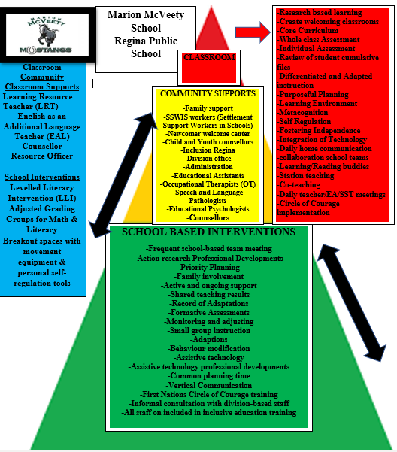
Figure 7
New Service Delivery Map Roles
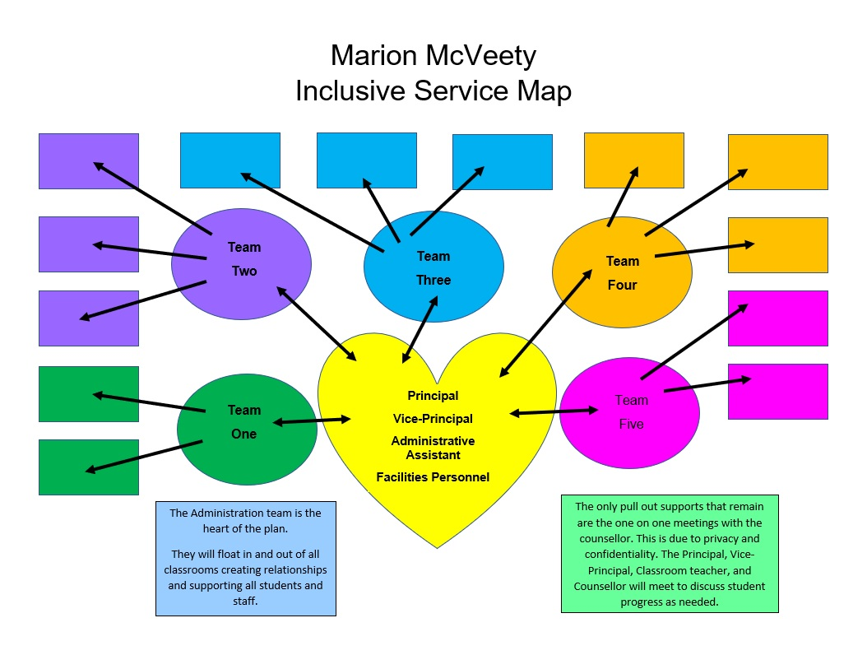
Step 4: Creating Instructional Teams
Inclusive leaders must carefully plan classroom configurations to ensure that classrooms are not overloaded with students requiring extra support. Next, the principal will create instructional teams, explain team expectations, schedule times for teams to meet, provide professional development opportunities, and provide leadership support consistently and frequently.
At Marion McVeety, classrooms are created collaboratively by a team of staff members who work with the students. Classrooms are organized around the concepts of “using natural proportions as a guide, it is important to strive for balanced or heterogenous classes that mix abilities, achievement, behaviour and other learning needs” (Causton & Theoharis, 2014, p. 53). The team discusses students and places each in well-balanced classrooms to ensure student success. After reviewing the current service maps with staff, it was decided to dismantle the self-contained pull-out programs (EAL, LRT, SLP) and redistribute the staff “to maximize the human resources to ensure all student’s participation and learning” (p. 64). By reallocating teachers, instruction will shift from pull-out support and move toward push-in support which will promote inclusivity.
Collaboration is essential to the success of inclusion. “Individuals alone cannot make inclusion happen; they must band together and work as a cohesive team. Each person brings something unique to the table, and when taken as whole powerful things can happen” (Timmons & Thompson, 2017, p. 11). Marion McVeety staff explained to the principal that many collaborative teaching arrangements already exist between grade-like classrooms. The principal used this information to guide the team configurations. Marion McVeety staff are organized in the leadership plan for inclusion into five collaborative teams. Each team includes a variety of strengths and experiences, and the team assignments are shown in Appendix K.
Additional Supports for All Teams
The principal, vice-principal, administrative assistant, and facilities personnel will form a collaborative team. They will be present and available throughout the day while visiting classrooms to build relationships and support staff and students. The occupational therapist, school resource officer, and Settlement Support Workers in Schools (SSWIS) will be a part of every team and will be informed and contacted once a month, or by need, by the principal on behalf of the team.
School Community Council members will be invited into the school to work within the teams as volunteers. Parents will be encouraged to offer suggestions and ideas to enhance the vision. Each team will also add to the lists of outside support agencies that can assist Marion McVeety throughout the year, such as Wascana Rehabilitation Centre and Inclusion Regina.
Teams will value the core goals of collaboration and recognize that “working with others can enhance creativity, improve reflection, increase respect for others, promote team collaboration and enhance self-efficacy” (Morel, 2014, p. 37) and that “all the adults on a teaching team must work together for the purpose of promoting student growth” (Causton & Theoharis, 2014, p. 75). Emphasizing the importance of relationships, the principal will promote and nurture that getting to know each other, professionally and personally, is key to the team’s success. Causton and Theoharis (2014) have outlined a List of Guiding Questions (see Appendix E) that teams will use during pre-arranged times to initiate productive dialogue. Principals will “set and supervise the inclusive instructional expectations” (Causton & Theoharis, 2014, p. 66) and clearly communicate the expectation that all teams will co-plan and co-deliver lessons to enhance learning for all students. Co-teaching is dependent on many factors and “Implementing co-teaching requires good communication skills among teachers based on reciprocity and experiences of equality” (Kokko et al., 2021, p. 126). Morel (2014) illustrates that the co-teaching environment should emphasize and demonstrate the importance of respect, trust, establishing high expectations, use of open communication, and consistent practices. Leaders will lead by example and embody these factors daily within the school. When these factors are present and effectively operating, the benefits of co-planning and co-teaching are numerous.
Kokko et al. (2021) state that “co-teaching increases teachers’ job satisfaction and well-being, it can reduce segregation, promote inclusion, improve students’ socio-emotional and interaction skills, and reduce students’ challenging behaviour” (p. 115). Students are better supported when there are more adults in the room. “According to teachers, co-teaching enables professional growth and collaboration and supports the development of teachers’ work” and “create(s) opportunities to learn new pedagogical approaches and content from one another” (p. 115). These benefits, attitudes, and practices will be adopted by staff members. A collaborative commitment to inclusion through the MUSTANGS acronym will guide the teams to make Marion McVeety an inclusive school.
The “core goal (for developing teams) is to bring together professionals who will share responsibility to work together to meet the needs of the wide range of learners in an inclusive setting under their joint care” (Causton & Theoharis, 2014, p. 6). Teams will work together to define roles and make decisions based on student need. It was decided that a major shift in the role of educational assistants must occur to foster student independence. According to the Student Support Services Delivery Model Rubrics (SSSDMR), Fostering Independence was emerging at Marion McVeety because educational assistants (EA) were assigned to classrooms, not students. However, they would still gravitate to specific students to provide one-on-one assistance. Each EA will be placed under the guidance of a classroom teacher and will assist in using a variety of co-teaching approaches. This will allow both adults to support all students in the classroom. As a direct result, there will be an increase in student independence. With intentional planning and discussions, the “Instructional teams need to plan meaningful roles for all adults” (p. 77). One way they will meet student needs and clearly define the roles will be through using a variety of co-teaching arrangements as seen in Figure 9.

Figure 9
Co-Teaching Arrangements
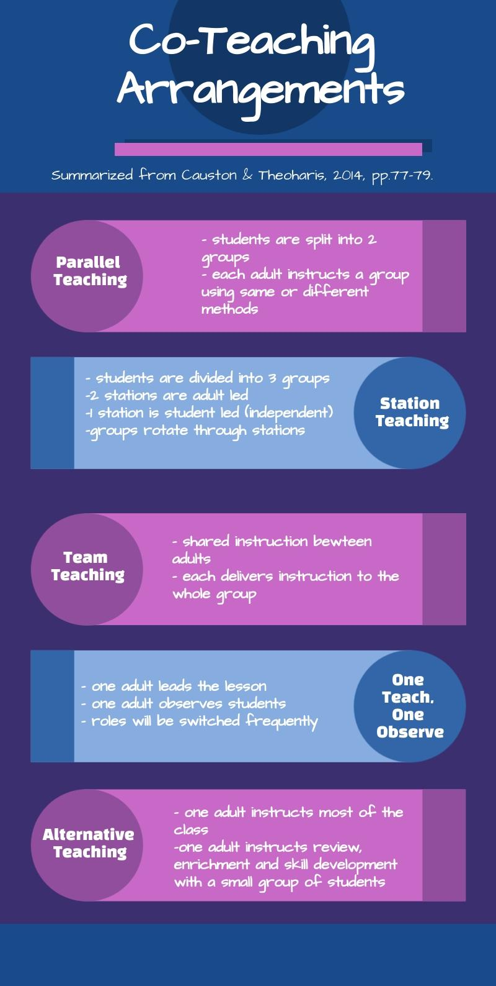

Additional suggestions for adult roles are provided by Causton & Theoharis in the chart: Ideas for Roles for Multiple Adults in the Classroom (see Appendix F). Principals will guide teams to work through the table, Determining Roles and Responsibilities Among Team Members (Appendix G). These questions will initiate important conversations and provide clear expectations for each team member. Change is a constantly evolving process and will require consistent reflection and modifications to roles and supports provided to students. Once co-teaching is underway, the principal and vice-principal will visit classrooms frequently. While there, they will make observations about the environment, relationships, what is working, and what can be adjusted to align with the school goals. One way to collect this data is to use the document taken from Causton and Theoharis, Instructional Team: Co-delivery of Instruction Feedback form (see Appendix H). Data from the visits will be shared with the team and used to celebrate successes, adjust goals, provide targeted support, and inform professional development opportunities. Constructive feedback and reflection will provide valuable data for the team to inform their next steps.
The most common barrier when using co-teaching has been identified as “the lack of common planning time” (Kokko et al, 2021, p. 115). Principals need to ensure that support is provided and create time for teams to meet. The preparation time needs to be built into the schedule and is to remain sacred. The librarian and specialists have particularly important roles in providing simultaneous preparation. Marion McVeety’s schedule has been meticulously designed to support teams with blocks of shared preparation time. In addition to the blocked preparation time, collaboration time is scheduled on Day 4 in the afternoon and will run on a rotational basis. To facilitate collaboration time, teachers will be assigned a Learning Buddy partner who is in the opposite team group. One-week Teams 1, 2, and 3 will meet, and the next week Teams 4 and 5 will meet. This allows all staff members to attend the team meetings every other week. One Buddy will facilitate Literacy and Numeracy Activities while the other one attends their scheduled team meeting. Professional development should be continuous and offered on a variety of topics brought to the principal by teams. Professional development should be “high quality”, “focused on the goals we have for teachers” and “promote individual and collective growth among teachers around topics that are important to staff” (Hoppey & McLeskey, 2013, p. 252). Time for professional development sessions and additional team meeting times are allotted on Professional Development days, at Lunch and Learn sessions, and creatively scheduling independent time for students. Keeping in mind that collaboration is not always scheduled and can happen during informal conversations throughout the day.
Teams acknowledge and recognize that conflicts do occur and will be equipped with strategies to help work through these disagreements. Conflicts are inevitable because “life is about dealing with different types of conflicts, for an individual, as well as for a social community” (Kokko et al., 2021, p. 117). Situations need to be discussed through guided conversations, active listening, and compromise. Like students are expected to do, “Teachers can use their individual differences as strengths to overcome challenges” (p. 116). By coming together and respectfully exchanging ideas and working through challenges, the team becomes stronger and realizes that together they are better.
Inclusive schools need principals who are dedicated and supportive in “both symbolic and material forms” (Causton & Theoharis, 2014, p. 72). They explain that symbolic forms include treating everyone equally and communicating to parents who are supporting each classroom by having both names on documents and classroom signs. Material forms include resources, manipulatives, and space for each adult in the classroom (p. 72). Principals need to be available, have open door policies, and be present in the school to provide whatever type of support staff and students need. Inclusive leadership reform emphasizes that “the Principal’s role in creating and leading inclusive instructional teams is one of the most crucial aspects of this work” (p. 85). It can be challenging, but “the magic of inclusive collaboration is much more likely to happen when the principal as a leader makes it a priority and plays this key role” (p. 85). With the implementation of instructional teams, clear expectations for staff and students, collaboration time, meaningful professional development opportunities, and unwavering support from the principal, Marion McVeety Mustangs are one step closer to becoming an inclusive school.
Step 5: Improving Classroom Practices
Inclusive classroom practices are essential to the Inclusive School Reform process. Collaboration is an underlying theme found in Causton and Theoharis’ (2014) Inclusive School Reform. The school community, including individuals in and out of the classroom, needs to collaborate to change their classroom practices to allow for co-teaching and differentiation (p. 54). Marion McVeety has inclusive processes in place; however, Marion McVeety could benefit from more support staff to meet the diverse needs of the students. Currently, there are two Educational Psychologists, two Occupational Therapists, a school counsellor, and a common school resource officer for the school population.
McLesky et al. (2014) present “A Classroom Model in which students with and without disabilities are based in regular structure and benefit from the shared ownership of general and special educators” (p. 34). The model consists of five processes to improve classroom practices. First, a student-centered approach through profiling students is taken. This determines the strengths and challenges of students. Second, a schedule is created that attempts to minimize
disruptions to students' learning. For instance, minimizing or eliminating the need for pull-out programs. Third, curriculum development through differentiated instruction is required. Fourth, a teaming process, where co-teaching and collaboration is vital to student success. Finally, the creation of a classroom climate that “embraces diversity, fosters a sense of social responsibility, and supports positive peer relationships” (p. 35).
Figure 10
General cycle of support (Causton & Theoharis, 2014, p. 99)
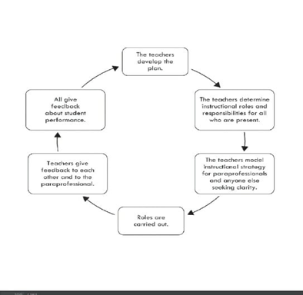

Figure 10 shows the General cycle of support. For effective collaboration to occur, this cycle must be adhered to. Accommodations, adaptations, or modifications are strategies that will ensure the success of students. Teachers need to profile their students to determine their strengths and be willing to adjust their instruction and assessment strategies to fit these needs. Additionally, students need to be part of the planning process. By allowing students a voice in their educational journey, it allows for engagement in the process. As educators, Marion McVeety should continue to hold academic standards and strive for that standard for all students (Causton & Theoharis, 2014). This may result in a change to how issues are addressed through modification strategies.
It is important to remember that no two students will learn exactly alike so educators must practice differentiated instruction to meet the needs of all students. Causton and Theoharis (2014) suggest instructional strategies such as giving tasks in a series of steps, providing extensions on deadlines, limiting information on a page, offering support, using a soft voice, and providing concrete examples (pp. 101-104). Teachers at Marion McVeety are also willing to teach organizational skills, provide alternative material to meet student’s needs, pre-teach comprehensive concepts, offer peer support opportunities, and encourage kinetic learning (pp. 104-105). Furthermore, teachers will advocate for assistive technologies that would suit students’ individual needs. Professional development is essential to improve classroom practices and ensure uniformity of all staff to an inclusive environment. An inclusive environment school-wide is the aim for Marion McVeety. Through the alternating teaching strategies, educators at Marion McVeety are well-positioned to improve their classroom practices.
Step 6: Ongoing Monitoring, Adjusting, and Celebrating
Once a plan is implemented, the process for the Inclusive School Reform does not end. Progress monitoring and revisions are vital to the success of the plan. Formative program review is essential to ensure forward motion and increase the potential of the inclusive plan rather than reverting to the past practices (Edmunds & Macmillan, 2010). As the plan is implemented, meetings will take place at the midpoint of the school year to monitor progress, make adjustments, and celebrate success. At the end of the school year, major adjustments to details and teaching schedules will be discussed and implemented for the following year (Causton & Theoharis, 2014, p. 54). Marion McVeety’s leadership plan team consists of whole-school community involvement where leaders, teachers, support services, paraprofessionals etc. are involved in planning, implementing, and monitoring progress.
Marion McVeety’s Leadership Plan for monitoring takes a two-prong approach. Data systems will be employed to assess the success and progress of the plan, and a problem-solving model called Team-Initiated Problem Solving (TIPS) will be used to address any issues identified. The ultimate goal of the inclusive environment is to ensure the achievement and quality of life for all students; by continually using evaluation and problem-solving strategies this goal can be achieved (McLesky et al., 2014).
Data systems have been used in various formats to assess the achievements of students and schools. Emerging data suggests “all schools need a school-wide data system that provides information that is useful for teachers and administrators in making critical decisions…” (McLesky et al., 2014, p. 157). Progress-monitoring systems are typically founded using curriculum-based measures where Response to Intervention (RtI) or multi-tiered instructional support systems (MTSS) are used to determine students’ academic successes. Despite the traditional usage, McLesky et al. (2014) argue that useful information can be gleaned “for the development and support of effective inclusive schools” (p. 157).
Three schools who have incorporated effective inclusive practices in the United States developed internal accountability systems where teachers acted on in-house student data rather than waiting for external data through state examinations. During the planning process, clear goals and objectives were made, and the internal accountability system tracked progress towards these goals through collected student data. The schools noted the internal accountability systems helped to change the frame of references for success as information gathered was helpful in determining inclusive curricular content and classroom instruction, and to guide professional development for alignment with program goals (McLesky et al., 2014).
The steps used in the data system for progress monitoring are to collect forms of data regarding student learning, analyze and interpret the data, form a hypothesis to improve outcomes, and then test the hypothesis by altering current strategies. Teachers at Marion McVeety would be responsible for data collection from their individual classrooms. Once data is collected, collaboration is key. A school-based facilitator will meet with teachers and teams to discuss data for decision-making and guide professional development as needed. Additionally, designated time is required for teacher collaboration to use data in decision making (McLesky et al., 2014).
To improve efficacy and ensure integrity, TIPS will be used as a problem-solving strategy. During regular meetings, as discussed in Step 1, a template is used for meeting minutes that addresses potential and current issues along with an action plan (see Appendix I). During meetings, using the TIPS model the team will follow the four steps. First, problems are identified, and a goal is defined. Identifying problems may be a result of evaluating school-wide data systems or concerns identified by team members. Careful consideration must be given to what is a true problem or a potential deviation to the initial plan. Second, solutions are discussed and selected. Third, an implementation plan is developed, and finally on-going evaluation will be employed (McLesky et al., 2014). As problems occur and strategies are discussed and employed, problem solving will become easier as the values and beliefs for inclusivity will be intrinsic within the team and school community.
Celebrating success is essential for continued support from the school community. Much like students’ successes are celebrated, there must also be celebration for the behind-the scenes work. As discussed by Edmunds and Macmillan (2010), without celebrating success through data analysis teachers may be unaware of the success that has occurred. During meetings, time will be set aside for teachers to discuss success rather than solely focusing on problem-solving. By celebrating success, morale can be improved and continued investment in the overall plan obtained.
Step 7: Ongoing: Create a Climate of Belonging
The desire to belong and feel that one is a part of a community is central to overall well-being. Every individual deserves to be welcomed as a valuable and contributing part of a shared community. When the need for belonging is positively met, there are holistic socio-emotional, physical, and cognitive benefits. Specht and Young (2010) cite Noddings (2002) and Rauner (2000), “The positive social, emotional and academic development of children and adolescents depends, to a considerable degree, on whether the contexts in which they develop, including schools, are reliable sources of caring relationships” (Edmunds & Mcmillan, 2010, pp. 65-66). Students spend a large amount of their early lives in a school environment. Causton and Theoharis (2014) state, “Helping students feel that they belong is one of the most important jobs of the paraprofessional and teacher, under the leadership of the principal” (p. 29). It is critical that the school administration and staff reflect on the attitudes, structures, and processes that will be adopted school-wide through attitudes and processes that assume student competence and are community-building.
All staff at a school are to be involved in the planning and implementation stages. Administrators should provide professional development on inclusive education and encourage open, positive, and productive dialogue among staff. By doing so, the school staff will be able to examine and shift attitudes towards a willingness to embrace the improvements to the inclusive environment. An attitude that should be adopted by teachers, paraprofessionals, and administration is the assumption of student competence.
Some educators may have shaped their personal perspectives around a deficit discourse, which is contrary to competence. Several of these are the lay discourse, the medical discourse, and the charity discourse. Each of these promotes a belief that students with disabilities are less capable than other students. Fraser and Shields (2010) indicate that it is the administration which needs “to promote an alternative discourse, such as a rights discourse, that positions those with disabilities as people first and foremost; as capable of contributing to school and society and as worthy - as anyone - of dignity and respect” (Edmunds & Macmillan, 2010, p. 12).
Assumptions of student competence are made possible using differentiated learning strategies and assessments. According to Alberta Education (2008), effective differentiated instruction recognizes, “Students learn at different rates and in different ways” (p. 21). Teachers can provide support through accommodations and/or modifications. When there are different ways of learning the material and choice on how to show learning, all students will be more engaged with the material and benefit academically. Marion McVeety elementary school serves a highly diverse community and many of its students are from other countries. The high number of EAL learners who attend will experience success with the comprehensive focus on differentiated instruction. The instructional teams that were set up during Step Two will engage in ongoing collaboration on differentiated instructional strategies and assessments.
During implementation of inclusionary practices, classroom teachers will work with administration and student support teachers and/or learning resources teachers to ensure that the expectations for students are appropriate and consistent. For all students to feel valued and have a sense of belonging, it is important for teachers to presume that every student will be successful, to use age-appropriate language, and to use person-first language. Administration will use the Belonging Feedback Form within a classroom periodically to assess the level to which the expectation of belonging is being met (see Appendix J). Specht and Young (2010) recommend that leaders, “Encourage staff to engage in positive behavioural supports,” and, “Implore teachers to create an environment of respect for different levels of accomplishment” (Edmunds & Macmillan, 2010, p. 67). In these ways, teachers can increase students’ feelings of competence and build community.
An inclusive school environment is focused on building a school-wide community where diversity is celebrated, and students feel respected. In 2019, a research study surveyed kindergarten teachers in Ontario to explore their perspectives on the inclusion of children with developmental disabilities. The results showed that, “While the majority of participants focused on the promotion of academic inclusion, a minority of teachers also addressed the need to promote a respectful and accepting classroom community to support inclusion in kindergarten” and the teachers felt they needed more supports in place to feel a greater sense of professional competency (Danniels & Pyle, 2021). Like the educators in the study, teachers at Marion McVeety are supportive of the philosophy of inclusion, and need ongoing educational opportunities, classroom support, and guidance when growing inclusive classroom communities. Administrators will support community building through welcoming parents and caregivers, providing ongoing communication to families, and involving parents and caregivers in discussing their child’s support needs. The school will adopt the Circle of Courage model within each classroom school-wide (see Figure 11). The philosophy behind this model is based on treating others with understanding and respect. The four core values of this model are: “belonging (a need to feel valued and important), mastery (developing competence), independence (responsibility for oneself), and generosity (genuine desire to help others)” (Alberta Education, 2008, p. 132). Strong community bonds will be created by incorporating a positive behaviour support model throughout the school, which will positively impact the climate of belonging.
Figure 11
Circle of Courage
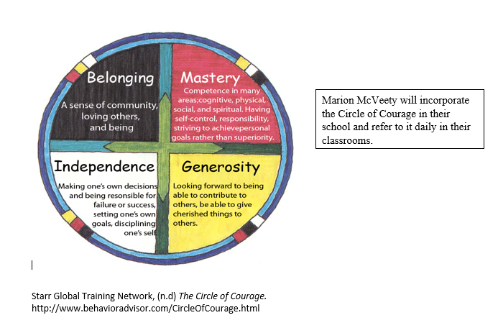
Conclusion
Successful school-wide and entrenched inclusion requires full commitment from administration. With this in place, principals can provide exemplary leadership as the school team and staff progress through the well-thought-out steps needed during the planning, implementing, and monitoring processes. In this assignment, the Inclusive School Reform Framework was used to develop the team leadership plan for inclusive education for Marion McVeety Elementary School (Causton & Theoharis, 2014, pp. 49-54). To accurately address areas for growth, it was necessary to consider Marion McVeety’s contextual situation regarding the community, students, and existing climate. The Support Services Service Delivery Model Rubric (2014) was used to assess the current inclusion environment at the school and provide direction for change. Common threads interwoven throughout each of the resulting and detailed framework steps were the needs for clear direction, shared vision, increased educational collaborations, and targeted professional development based on areas for growth. A revised focus statement, MUSTANGS, provided guiding principles to inform school-wide attitudes and beliefs in the shift to full inclusion. As Marion McVeety steps forwards with the active implementation of the leadership plan for an inclusive environment, there is promise of a bright future that attempts to fully embrace all students, celebrating their strengths and appreciating diversity.

References
Alberta Education. (2008). Supporting positive behaviour in Alberta schools: a school-wide approach. Edmonton, AB: Author.
Billingsley, B., DeMatthews, D., Connally, K., & McLesky, J. (2018). Leadership for effective inclusive schools: Considerations for preparation and reform. Australasian Journal of Special and Inclusive Education, 42(1), 65-81. DOI: 10.1017/jsi.2018.6
Causton, J., & Theoharis, G. (2014). The principal’s handbook for leading inclusive schools. Brookes Publishing.
Danniels, E., & Pyle, A. (2021). Promoting inclusion in play for students with developmental disabilities: Kindergarten teachers’ perspectives. International Journal of Inclusive Education. DOI: 10.1080.13603116.2021.1941316
Edmunds, A. L., & Macmillan, R. B. (Eds.). (2010). Leadership for inclusion: A practical guide (3rd ed.). Sense Publishers.
Government of Saskatchewan. (2017). Accessing professional supports: Saskatchewan guidelines for school division professional services. https://microsite-sws-prod.s3.amazonaws.com/media/editor/24/Accessing_Professional_Supports_.pdf
Hoppey, D., & McLesky, J. (2013). A case study of principal leadership in an effective inclusive school. The Journal of Special Education, 46(4), 245-256.
Kokko, M., Takala, M., & Pihlaja, P. (2021). Finnish teachers’ views on co-teaching. British Journal of Special Education, 48(1), 112-132. DOI: 10.1111/1467-8578.12348
McLeskey, J., Waldron, N. L., Spooner, F., & Algozzine, B. (Eds.). (2014). Handbook of effective inclusive schools: Research and practice. Routledge.
Morel, N. J. (2014). Setting the stage for collaboration: An essential skill for professional growth. The Delta Kappa Gamma Bulletin, 81(1), 36.
Saskatchewan Ministry of Education. (2014). Student support services service delivery model rubrics. Regina, SK: Author.
Saskatchewan Ministry of Education. (2019). Inclusive education: A guide for school-based leaders. Regina, SK: Author.
Theoharis, G., & Causton, J. (2014). Leading inclusive reform for students with disabilities: A school-and systemwide approach. Theory Into Practice, 53(2), 82-97. DOI: 10.1080/00405841.2014.885808
Timmons, V., & Thompson, S.A. (2017). Voices of inclusion. EDL 825. UR Courses. Module 7.
Waitoller, F. R., & Artiles, A. J. (2013). A decade of professional development research for inclusive education: A critical review and notes for a research program. Review of Educational Research, 83(3), 319-356. DOI: 10.3102/0034654313483905
Wood, H., O’Farrell, K., Bjerk-Andersen, C., Mullen, C., & Kovshoff, H. (2019). The impact of Planning Alternative Tomorrows with Hope (PATH) for children and young people. Educational Psychology in Practice, 35(3), 326-338.
DOI: 10.1080/02667363.2019.1604323

Appendix A

PATH Visual
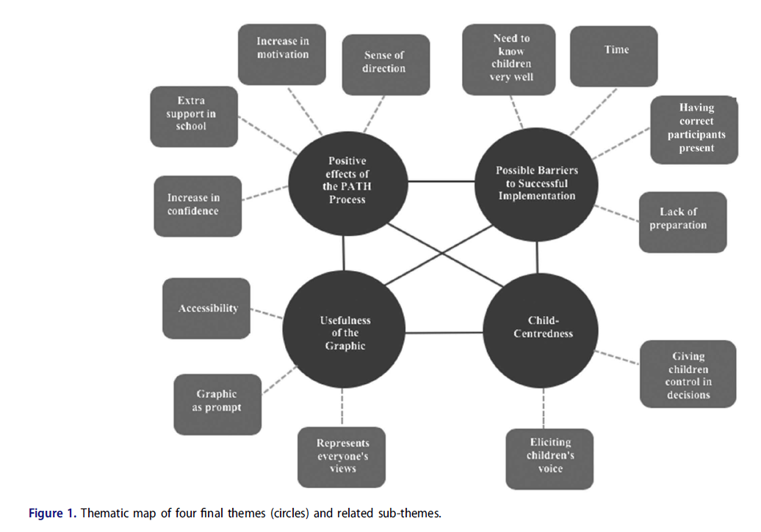
(Wood et al., 2019, p. 332)

Appendix B
Marion McVeety Assessment Using Student Support Services Service Model Rubrics
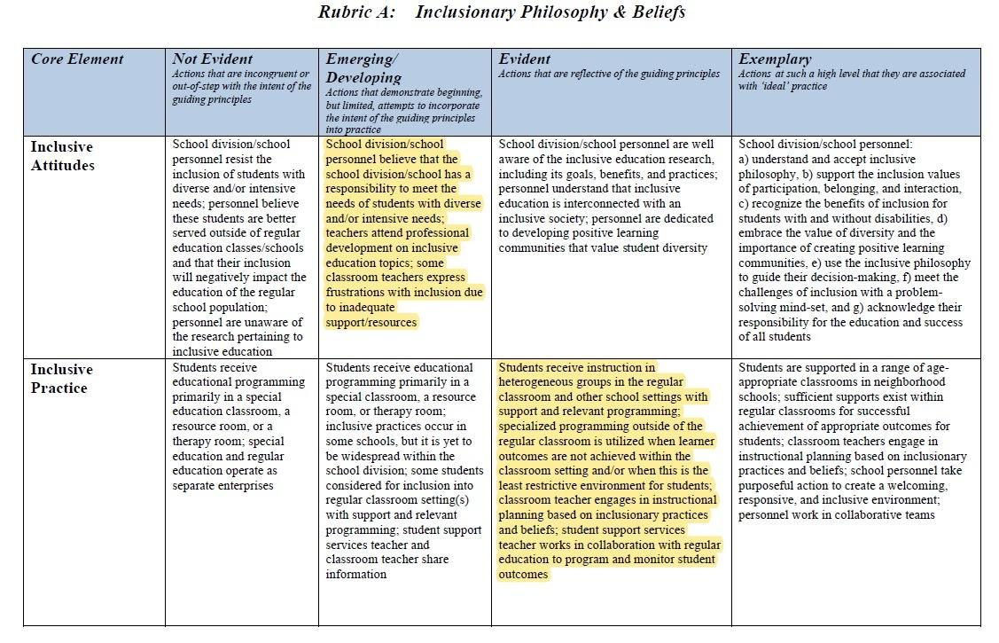
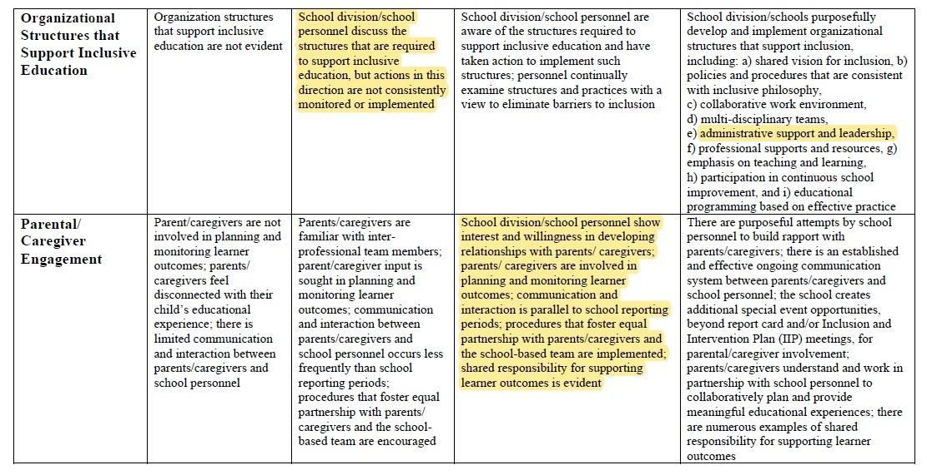
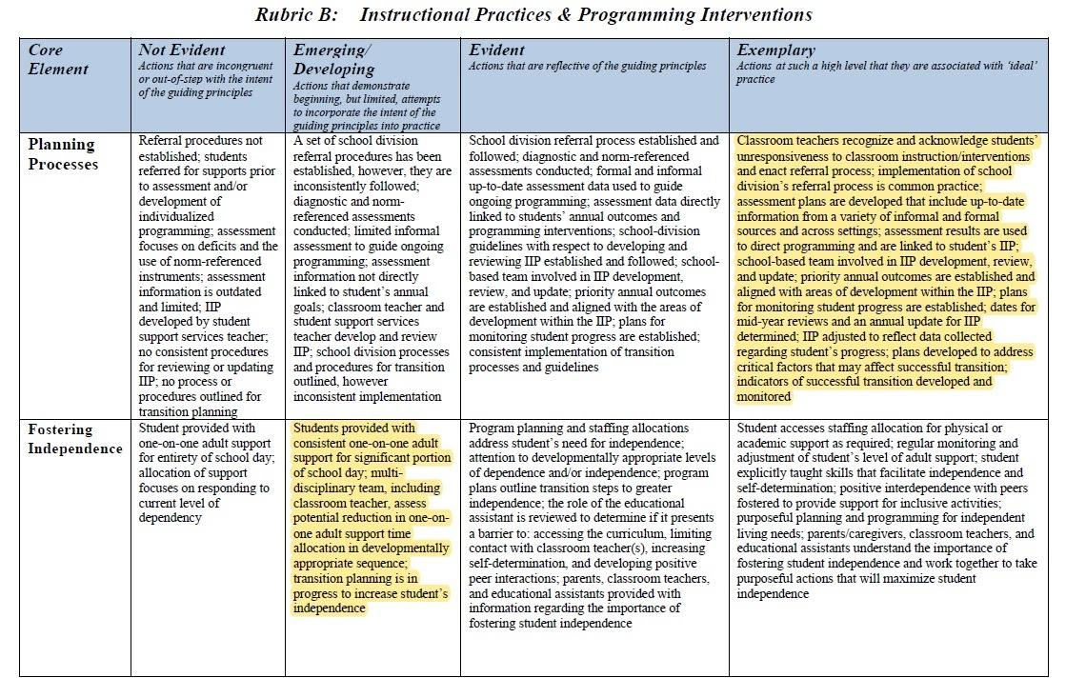
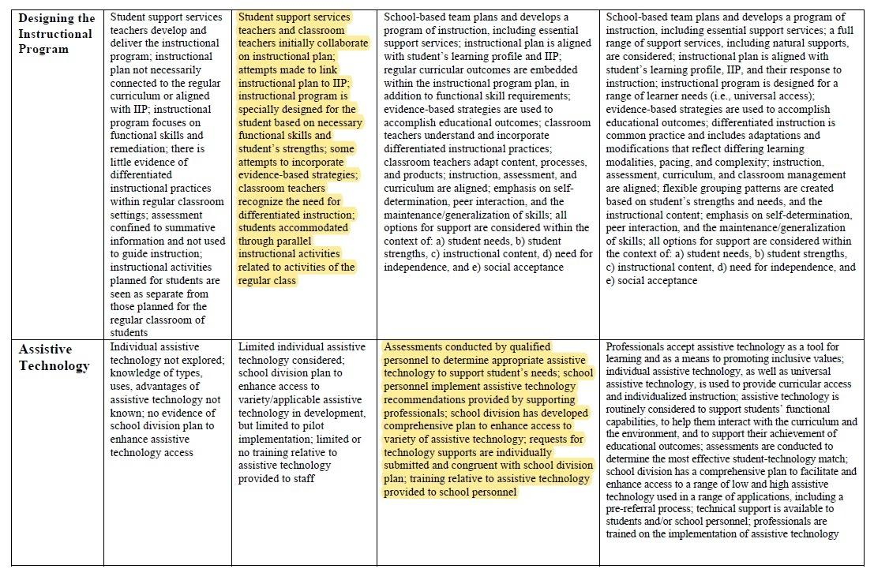
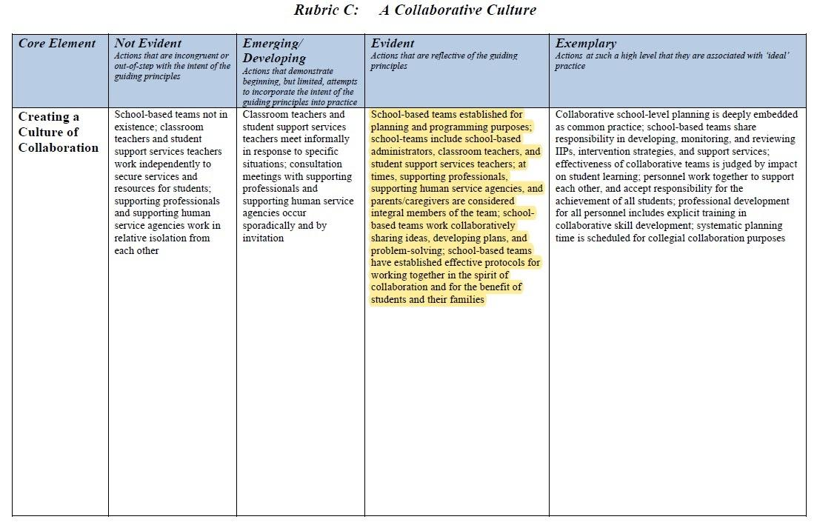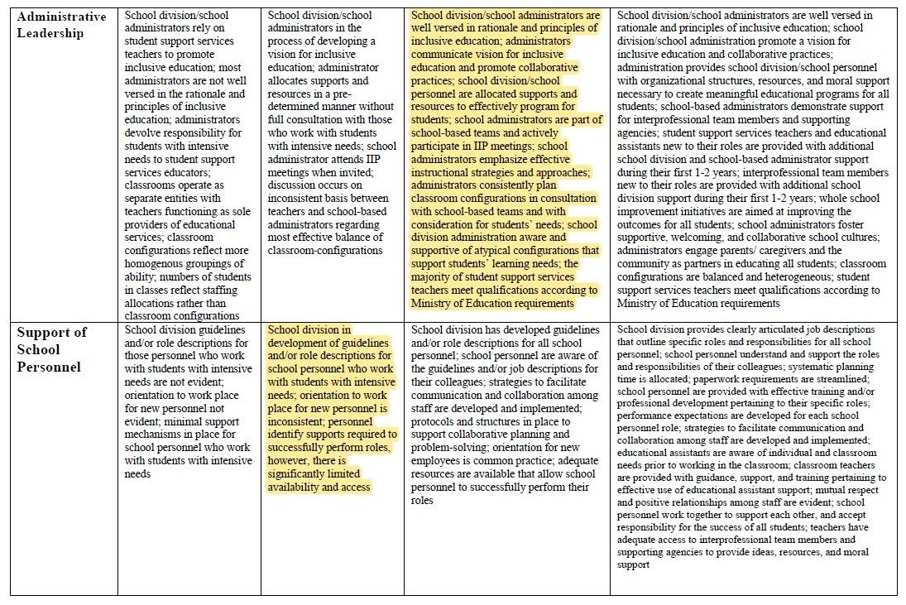
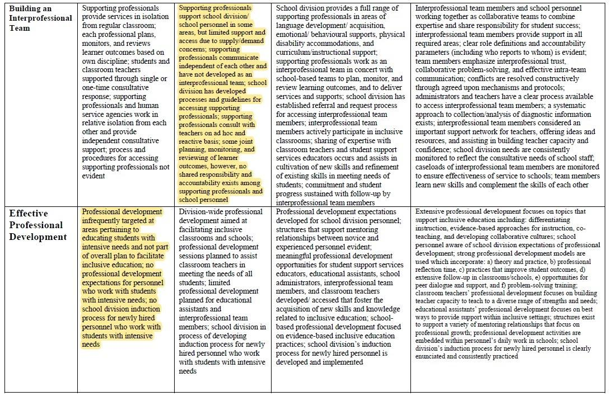
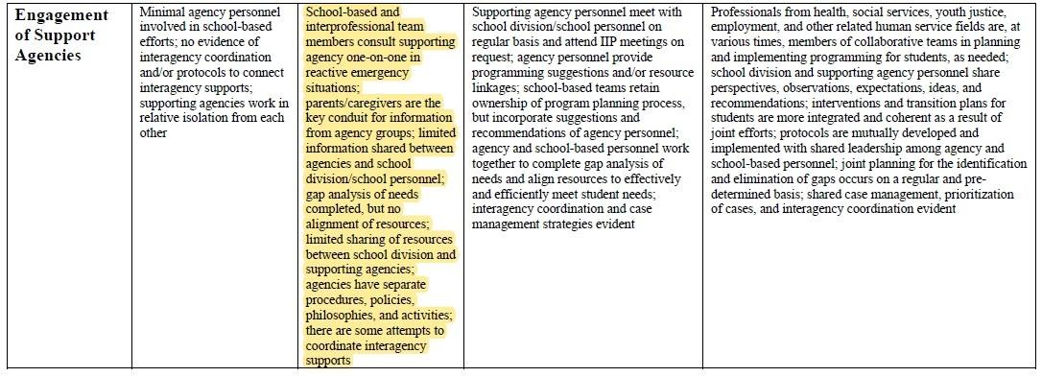(Saskatchewan Ministry of Education, 2014).

Appendix C
Marion McVeety Teacher Strategy Form

Student: | Teacher: | Review Date: | Grade:
Review and Evaluate Intervention Plan
Interventions to be implemented |  | Outcome
Additional Notes/Discussion
Checklist for Teachers
- I have reviewed student documents in CLEVR
- I have recorded the key adaptations in the student’s ROA
- I have reviewed the cumulative file
- I have discussed my concerns with the family (include dates) _______________, _______________,
- I have discussed my concerns with school staff
- I have discussed my concerns with the classroom LRT
What are the student’s strengths?

What does the student need?

What is working for the student? |  | What is not working for the student?

Appendix D
MUSTANG Resources
This document is a starting point and will become a shared collaborative resource. All images are linked to videos.
Mistakes are opportunities for growth. |  |  | 
Unity and understanding are expected. |  |  | 
Safe and supportive environments help us succeed. | 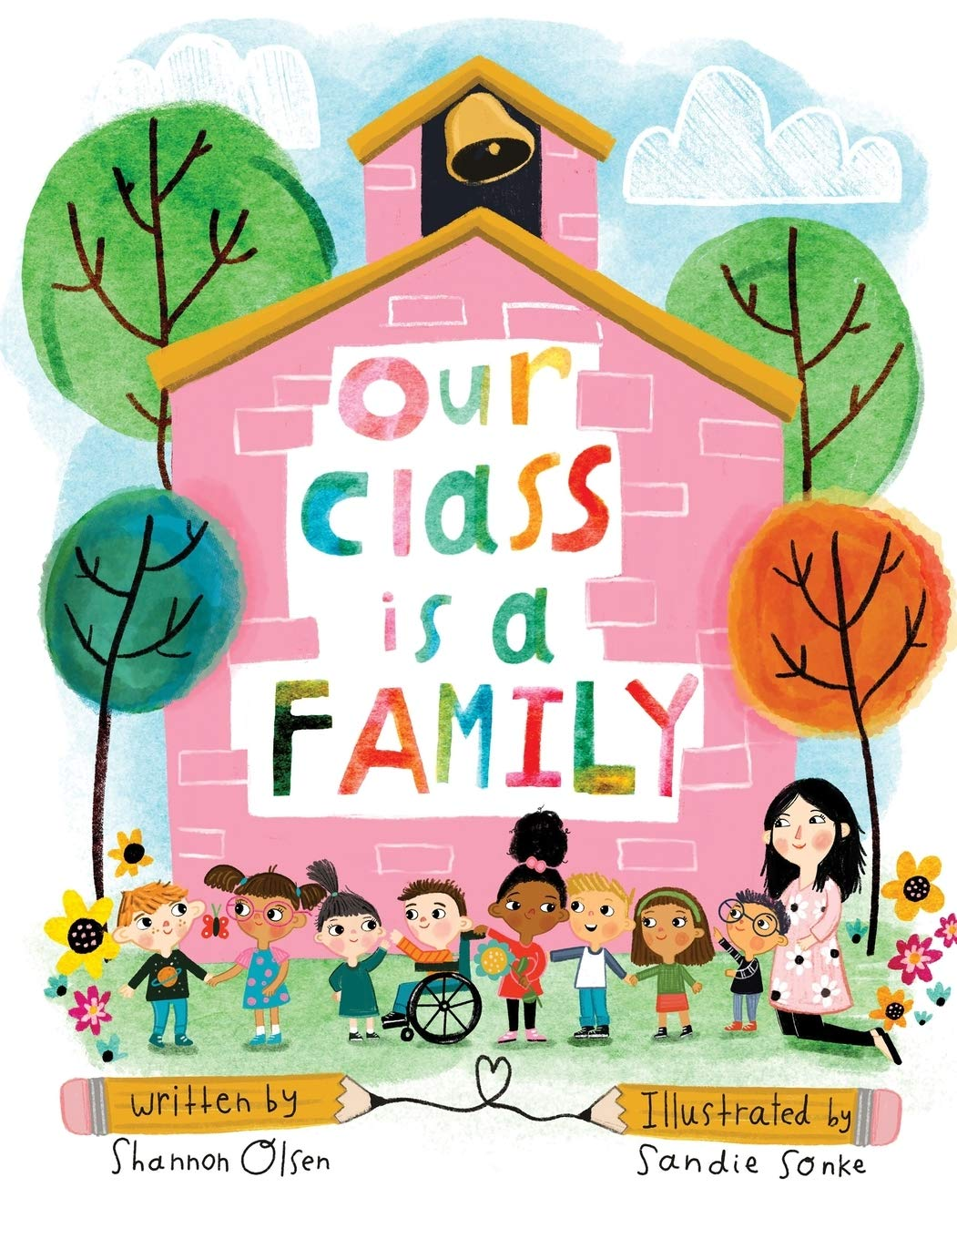 |  | 
Teamwork is key. | 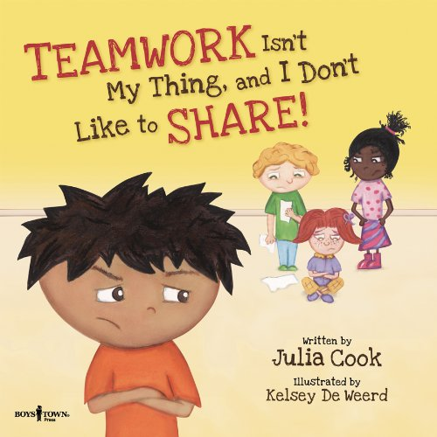 |  | 
All are welcome and accepted. |  |  | 
New perspectives and ideas are valued. |  |  | 
Grouping students to meet the needs of all learners. |  |  | 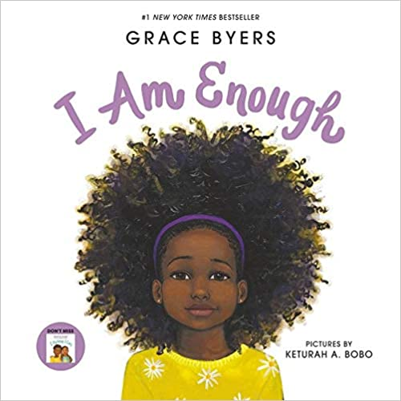
Strength is diversity. |  |  | 
Difference is the norm at Marion McVeety.

Appendix E
Guiding Questions for Instructional Teams

Work Styles

- Are you a morning or afternoon person?
- How direct are you?
- Do you like to do several things at once, or do you prefer to do one thing at a time?
- How do you prefer to give feedback to others on the team?
- What do you consider your strengths and weaknesses when working in a team situation?

Philosophy

- To me, advanced planning means…
- All kids learn best when…
- In general, I think the best way to deal with challenging behaviour is…
- In general, I think it is important to increase student independence by…
- I think our team relationship needs to be...

Logistics

- How should we communicate about students’ history and progress?
- How should we communicate about our roles and responsibilities?
- How and when should we communicate about lessons and modifications?
- If we do not know an answer in class, should I direct the student to you?
- Do we meet often enough? If not, when should we meet?
- How do we communicate with the families? What is each person’s role in this?
- Are there other logistical concerns?

Questions for the Family

- How would you like to communicate about your child’s progress?
- If we are using a communication notebook or e-mail, how often would you like to hear from the school?
- Are there things you are especially interested in hearing about?

(Causton & Theoharis, 2014, pp. 76-77)

Appendix F
Ideas for Roles for Multiple Adults in the Classroom
Table 5.1
If one teacher is doing this: | Another teacher can be doing this:
Lecturing | Modelling note taking on the board, drawing the ideas on the board, or taking notes on the overhead
Taking Attendance | Collecting and receiving homework
Giving Directions | Writing directions on the board so all students have a place to look for visual cues
Providing large-group instruction | Collecting data on student behaviour or engagement, or making modifications for an upcoming lesson
Giving a test | Reading the test to students who prefer to have the test read to them
Facilitating stations or small groups | Also facilitating stations or groups
Facilitating sustained, silent reading | Reading aloud quietly with a small group
Teaching a new concept | Providing visuals or models to enhance the whole group’s understanding
Reteaching or pre teaching with a small group | Monitoring the large group as students work independently

(Causton & Theoharis, 2014, p. 79)

Appendix G
Determining Roles and Responsibilities Among Team Members
Directions: Read through the following common roles and responsibilities. Determine which team member should take on each of the roles and responsibilities:
P = Primary responsibility S = Secondary responsibility
Sh = Shared responsibility I = Input in the decision making
Major role or responsibility | Classroom Teacher | Special Education Teacher | Therapist | Paraprofessional
Developing student objectives
Designing differentiated curriculum
Creating student-specific modifications and adaptations
Creating classroom materials
Co-teaching curriculum
Providing one-to-one instruction
Teaching the whole class of students
Leading small groups
Monitoring student progress
Examining student work to determine next steps
Assessing and assigning grades
Communicating with parents
Consulting with related service personnel
Participating in IEP meetings
Disciplining students
Writing in communication notebooks
Providing community-based programming
Developing peer supports
Scheduling common planning time
Participating in regularly scheduled team planning meetings
Facilitating meetings
Communicating information from meetings to other team members
Other
When you have finished determining the roles and responsibilities for each of the team members, ask yourselves the following questions:

- Could any of these roles and responsibilities be shared or changed?
- Does anyone feel uncomfortable with any of the roles as outlined?
- Does anyone believe he or she needs more information or training to perform the above-mentioned responsibilities?
- What messages are sent to students, parents, and others about the way adults work together as a team in this classroom through the division of responsibilities?
- What changes need to be made?

(Causton & Theoharis, 2014, pp. 80-81)

Appendix H
Instructional Team: Co-Delivery of Instruction Feedback Form
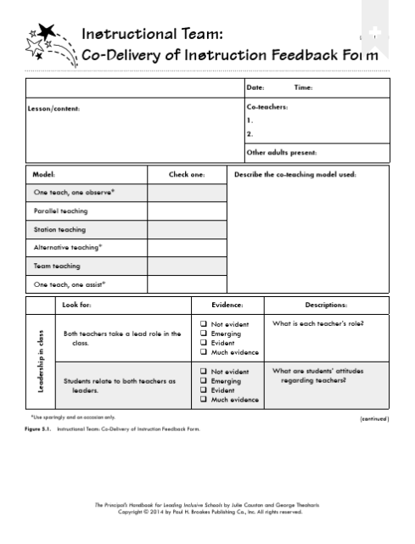

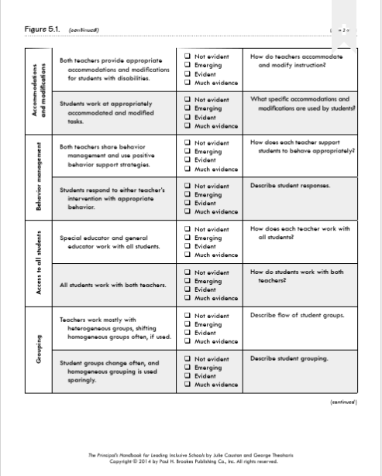
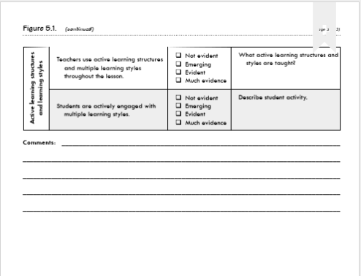
(Causton & Theoharis, 2014, pp. 67-69)

Appendix I
Meeting Template
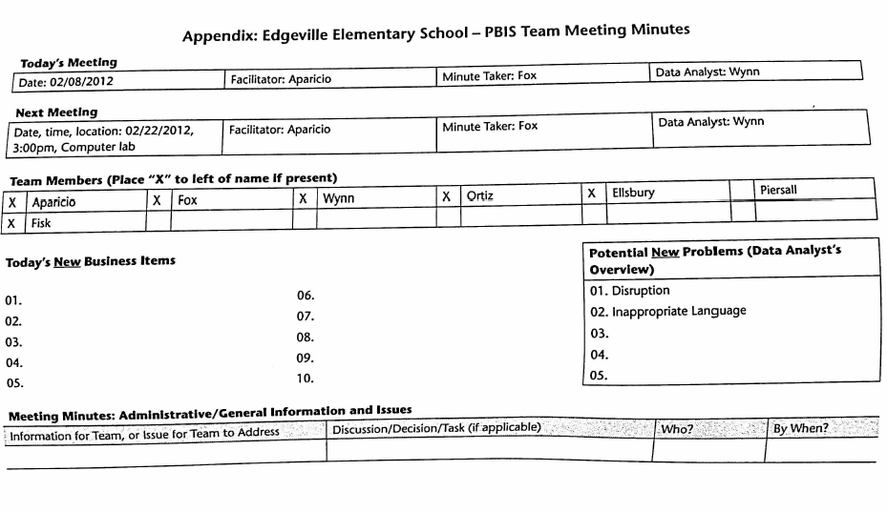 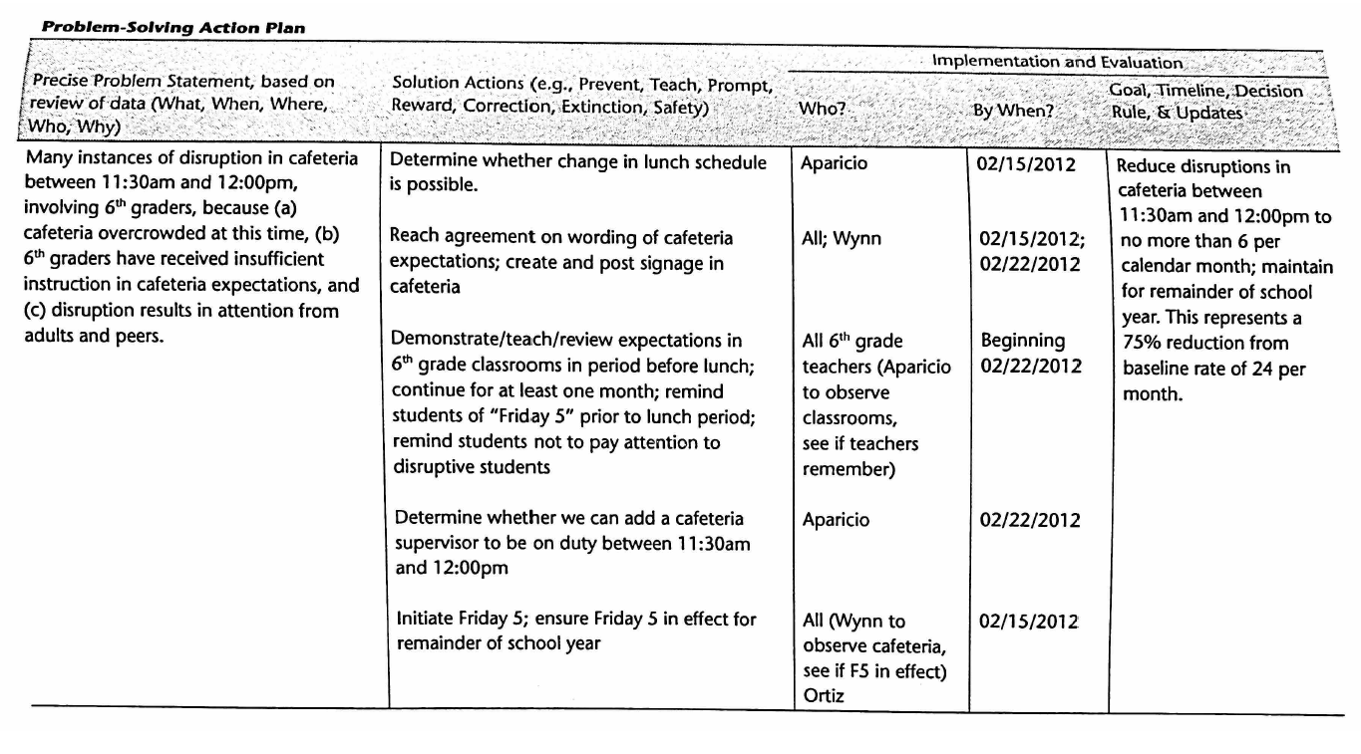 (McLesky et al., 2014, pp. 290-291)

Appendix J
Belonging Feedback Form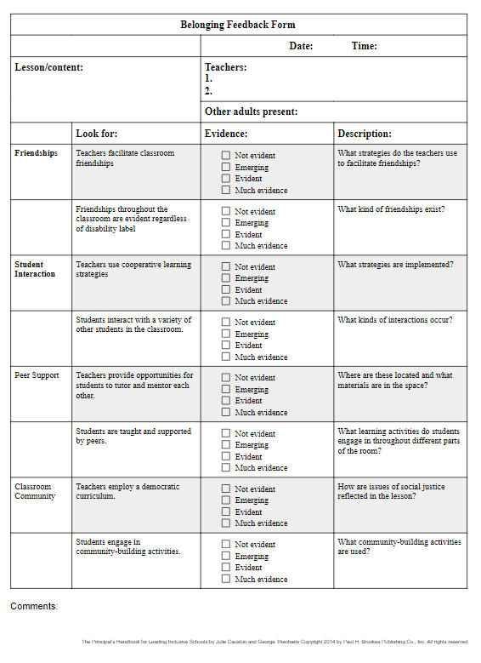
(Causton & Theoharis, 2014, pp. 57-58)
Appendix K
Marion McVeety Instructional Teams
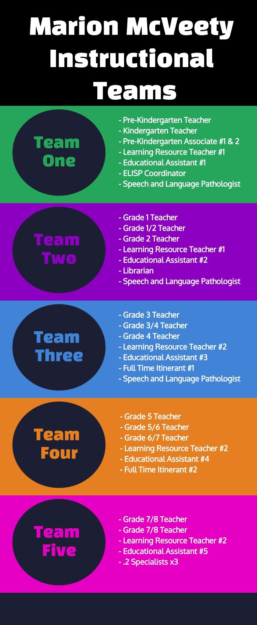

Appendix L
Additional Resources
Please see the following resource for valuable additional information: Accessing Professional Support.

